**Review Worksheet: Intro to Biotechnology / PCR**

**Name: ……………………………………………………………..**

*Do these questions, using your learning resources. Look at the “marks” to give you an idea of the level of detail required in the response (formative only – does not count towards your grade). At the end, mark your work, correct it, and fill in the reflection section. Questions marked * require you to use reasoning, inferring and application of knowledge, or perhaps extra research to get the answer. It won’t be right there in the text.*

1: What is biotechnology?

(1 mark)

…………………………………………………………………………………………………………………..

…………………………………………………………………………………………………………………..

2: Give three examples of modern biotechnological techniques.

(3 marks)

…………………………………………………………………………………………………………………..

…………………………………………………………………………………………………………………..

…………………………………………………………………………………………………………………..

…………………………………………………………………………………………………………………..

3: What is the Human Genome Project, and what are some potential benefits?

(4 marks)

…………………………………………………………………………………………………………………..

…………………………………………………………………………………………………………………..

…………………………………………………………………………………………………………………..

…………………………………………………………………………………………………………………..

…………………………………………………………………………………………………………………..

…………………………………………………………………………………………………………………..

4: What is the overall purpose of Polymerase Chain Reaction (PCR)?

(2 marks)

…………………………………………………………………………………………………………………..

…………………………………………………………………………………………………………………..

…………………………………………………………………………………………………………………..

…………………………………………………………………………………………………………………..

5: What are the main ingredients in the PCR process and what does each do?

(4 marks)

…………………………………………………………………………………………………………………..

…………………………………………………………………………………………………………………..

…………………………………………………………………………………………………………………..

…………………………………………………………………………………………………………………..

6: Describe in detail the steps in the PCR process.

(10 marks)

…………………………………………………………………………………………………………………..

…………………………………………………………………………………………………………………..

…………………………………………………………………………………………………………………..

…………………………………………………………………………………………………………………..

…………………………………………………………………………………………………………………..

…………………………………………………………………………………………………………………..

…………………………………………………………………………………………………………………..

…………………………………………………………………………………………………………………..

…………………………………………………………………………………………………………………..

…………………………………………………………………………………………………………………..

…………………………………………………………………………………………………………………..

…………………………………………………………………………………………………………………..

…………………………………………………………………………………………………………………..

7: Why can’t human DNA polymerase be used in the PCR process?

(3 marks)

…………………………………………………………………………………………………………………..

…………………………………………………………………………………………………………………..

…………………………………………………………………………………………………………………..

…………………………………………………………………………………………………………………..

8: What is the origin of *Taq* polymerase and why can it be used successfully in PCR?

(3 marks)

…………………………………………………………………………………………………………………..

…………………………………………………………………………………………………………………..

…………………………………………………………………………………………………………………..

…………………………………………………………………………………………………………………..

9: What do you think the water temperature would be near the geothermal vents where *Thermus aquaticus* lives? Explain your answer.*

(3 marks)

…………………………………………………………………………………………………………………..

…………………………………………………………………………………………………………………..

…………………………………………………………………………………………………………………..

…………………………………………………………………………………………………………………..

10: Which part of the PCR process is indicated by each letter on the diagram shown?

(4 marks)

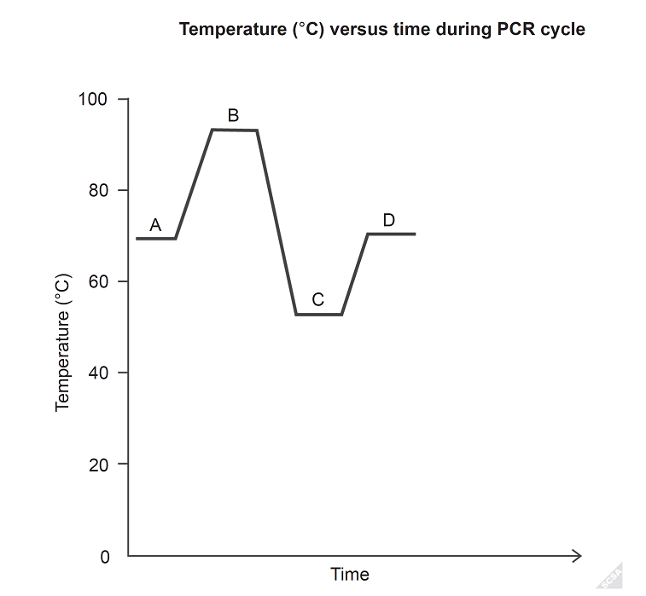

A: ……………………………………………

B: ……………………………………………

C: ……………………………………………

D: ……………………………………………

11: List applications of PCR.

(4 marks)

…………………………………………………………………………………………………………………..

…………………………………………………………………………………………………………………..

…………………………………………………………………………………………………………………..

…………………………………………………………………………………………………………………..



12: List the principles of evolution by natural selection.

(6 marks)

…………………………………………………………………………………………………………………..

…………………………………………………………………………………………………………………..

…………………………………………………………………………………………………………………..

…………………………………………………………………………………………………………………..

…………………………………………………………………………………………………………………..

…………………………………………………………………………………………………………………..

…………………………………………………………………………………………………………………..

…………………………………………………………………………………………………………………..

…………………………………………………………………………………………………………………..

…………………………………………………………………………………………………………………..

…………………………………………………………………………………………………………………..

…………………………………………………………………………………………………………………..

Go back and mark your work using the marking key provided. What score did you get? /47

*I included enough detail in my answers.*



*I was able to find information in the text/powerpoint presentation.*

*I was able to reason and infer where the information wasn’t directly in the text (questions with *).*

*I marked my work and wrote down any answers where I missed marks.*